CSS2 ASSIGNMENT

SubmitBy-

Mithlendu Kumar

QN1 Change Background Color of a Single Cell

Output

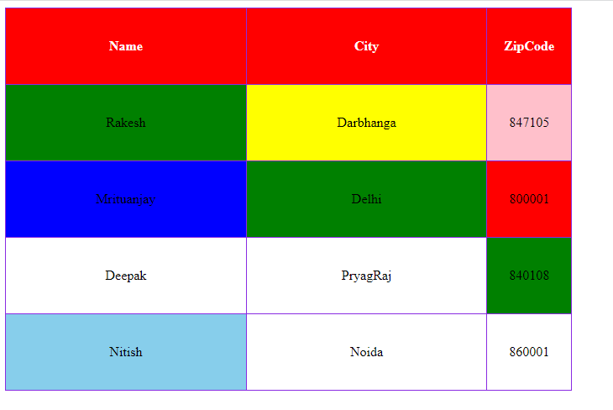

Code

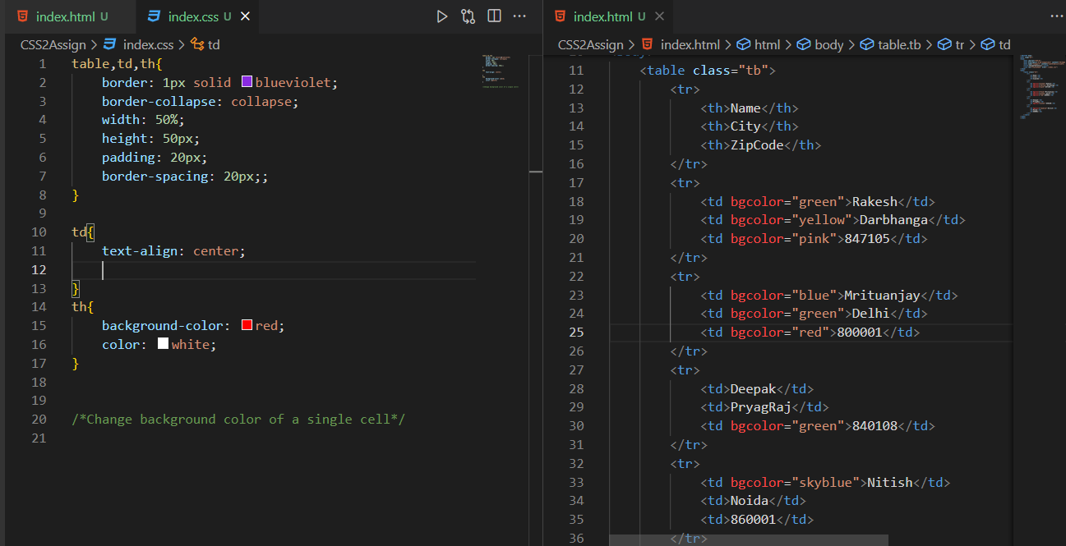

QN2 Change Background color with property value i.e even and odd

Output



Code

